Step 1 create a new MVC Project

Right click on Models folder 🡺 addnew Class (Customer.cs)

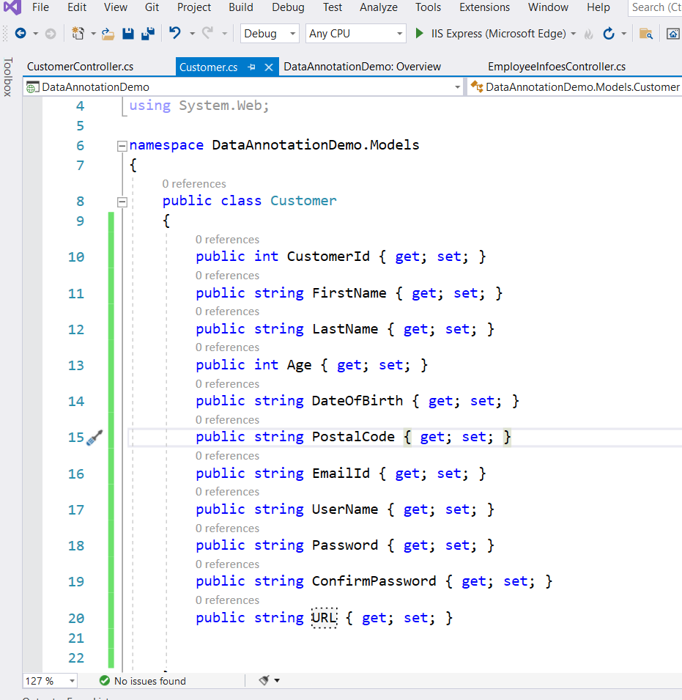

Right click on Controllers 🡺 Add new Controller🡺 mvc Controller with read and write actions

Controller name CustomerController

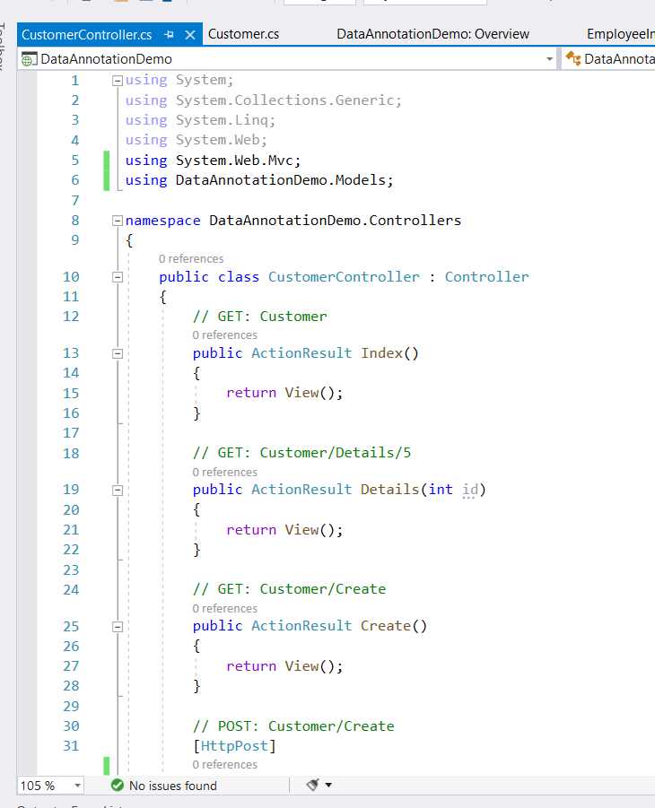

using System;

using System.Collections.Generic;

using System.Linq;

using System.Web;

using System.Web.Mvc;

using DataAnnotationDemo.Models;

namespace DataAnnotationDemo.Controllers

{

public class CustomerController : Controller

{

// GET: Customer

public ActionResult Index()

{

return View();

}

// GET: Customer/Details/5

public ActionResult Details(int id)

{

return View();

}

// GET: Customer/Create

public ActionResult Create()

{

return View();

}

// POST: Customer/Create

[HttpPost]

public ActionResult Create(Customer customer)

{

try

{

if(ModelState.IsValid)

{

return RedirectToAction("Index");

}

// TODO: Add insert logic here

return View();

}

catch

{

return View();

}

}

// GET: Customer/Edit/5

public ActionResult Edit(int id)

{

return View();

}

// POST: Customer/Edit/5

[HttpPost]

public ActionResult Edit(int id, FormCollection collection)

{

try

{

// TODO: Add update logic here

return RedirectToAction("Index");

}

catch

{

return View();

}

}

// GET: Customer/Delete/5

public ActionResult Delete(int id)

{

return View();

}

// POST: Customer/Delete/5

[HttpPost]

public ActionResult Delete(int id, FormCollection collection)

{

try

{

// TODO: Add delete logic here

return RedirectToAction("Index");

}

catch

{

return View();

}

}

}

}

Add create view for Customer Controller.

Right click on create action method in CustomerController.

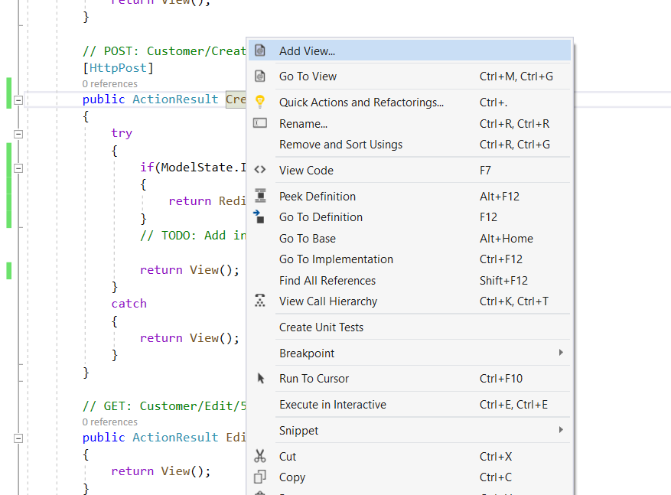

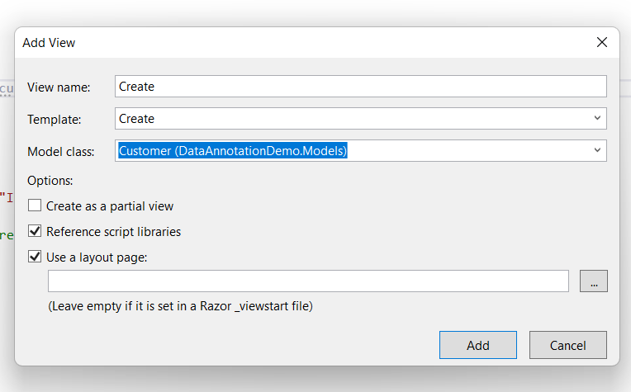

To enable Cient-side and server side validation 🡺 Goto web.config

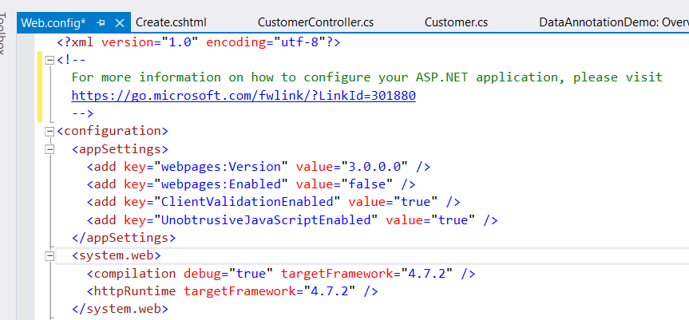

In Layout.cshtml

Add below 3 script in it.

